Float Data Types
# Source: AI Source: Provided by: [Data Path: Persons Table -> ID Column: 1, Name_En Column: Motasem Essam] -> From: [Chatgpt (GPT‑5 Mini)] on [12/10/2025]
A float is a data type used to store decimal numbers (numbers that have a fractional part).

Key Characteristics
# Source: AI Source: Provided by: [Data Path: Persons Table -> ID Column: 1, Name_En Column: Motasem Essam] -> From: [Chatgpt (GPT‑5 Mini)] on [12/10/2025]
- Stores numbers with decimal points
- Uses single-precision floating-point format
- Consumes 4 bytes (32 bits) of memory in many programming languages
- Less precise than double, but uses less memory

Example Values
# Source: AI Source: Provided by: [Data Path: Persons Table -> ID Column: 1, Name_En Column: Motasem Essam] -> From: [Chatgpt (GPT‑5 Mini)] on [12/10/2025]
3.14
0.5
-8.75
12.0

Example in Programming

C / C++ / Java
# Source: AI Source: Provided by: [Data Path: Persons Table -> ID Column: 1, Name_En Column: Motasem Essam] -> From: [Chatgpt (GPT‑5 Mini)] on [12/10/2025]
float price = 19.99;
float temperature = 36.5;
float distance = 12.75;

Python
# Source: AI Source: Provided by: [Data Path: Persons Table -> ID Column: 1, Name_En Column: Motasem Essam] -> From: [Chatgpt (GPT‑5 Mini)] on [12/10/2025]
price = 19.99
temperature = 36.5
distance = 12.75

Memory and Range (Typical)
# Source: AI Source: Provided by: [Data Path: Persons Table -> ID Column: 1, Name_En Column: Motasem Essam] -> From: [Chatgpt (GPT‑5 Mini)] on [12/10/2025]
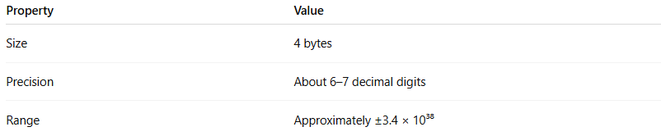
Property | Value
Size | 4 bytes
Precision | About 6–7 decimal digits
Range | Approximately ±3.4 × 10³⁸

Example Calculation
# Source: AI Source: Provided by: [Data Path: Persons Table -> ID Column: 1, Name_En Column: Motasem Essam] -> From: [Chatgpt (GPT‑5 Mini)] on [12/10/2025]
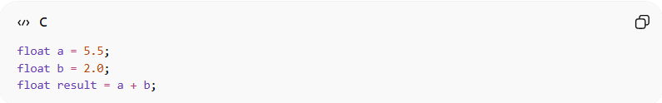
float a = 5.5;
float b = 2.0;
float result = a + b;
Result: 7.5

When to Use float
# Source: AI Source: Provided by: [Data Path: Persons Table -> ID Column: 1, Name_En Column: Motasem Essam] -> From: [Chatgpt (GPT‑5 Mini)] on [12/10/2025]
Use float when:
- You need decimal numbers
- Memory usage matters
- Very high precision is not required
Examples:
- Temperature values
- Measurements
- Graphics calculations
- Scientific approximations

Float vs Double
# Source: AI Source: Provided by: [Data Path: Persons Table -> ID Column: 1, Name_En Column: Motasem Essam] -> From: [Chatgpt (GPT‑5 Mini)] on [12/10/2025]
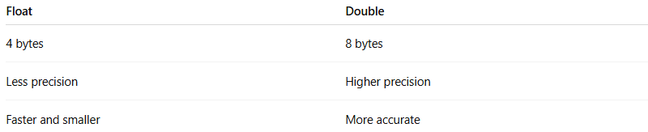
Float | Double
4 bytes | 8 bytes
Less precision | Higher precision
Faster and smaller | More accurate

